https://dev.d24jig8s1lr7n9.amplifyapp.com/ Final project

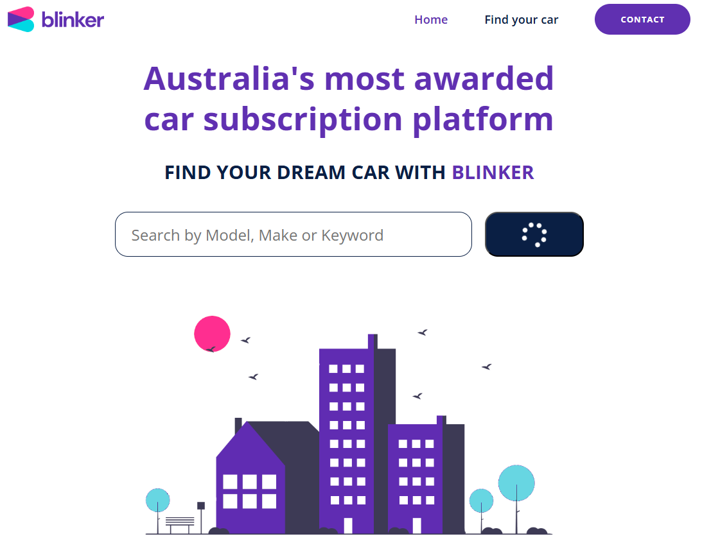

<footer>

</footer>

===============

Final Project
In this project, you will be building out a real-world take home interview for a $80,000-$90,000 frontend developer role using everything we have learnt in the HTML, CSS and JavaScript sections.

Important submission requirements for this project:
Your final project must include:
• A footer
• A working sorting filter
For the sorting filter, keep it simple. Examples:
• Alphabetical A to Z
• Alphabetical Z to A
• Newest to oldest
• Oldest to newest

Note: You do not need sliders or fancy controls. We are checking that your sorting works correctly, not how complex your design is. Goodluck :)

Example of FILTER
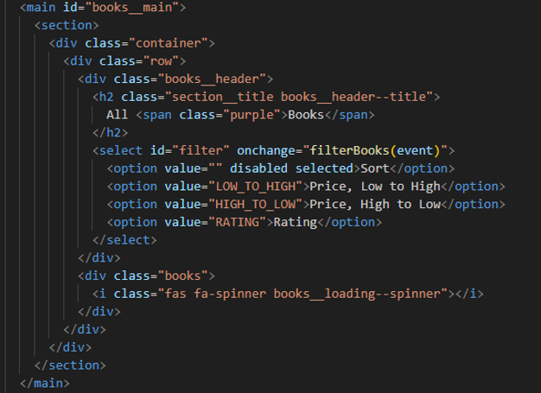

EmailjS
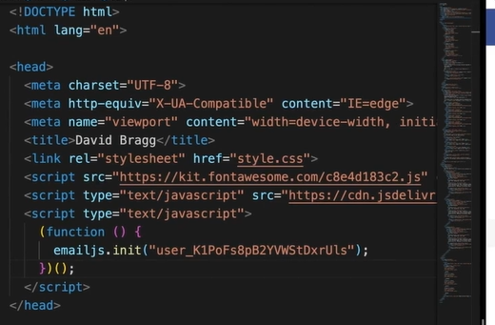
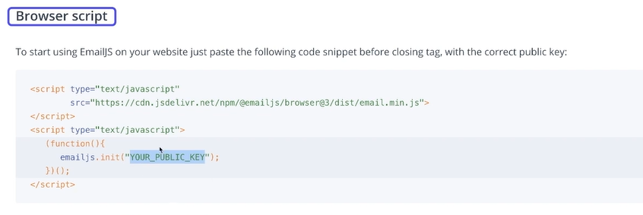

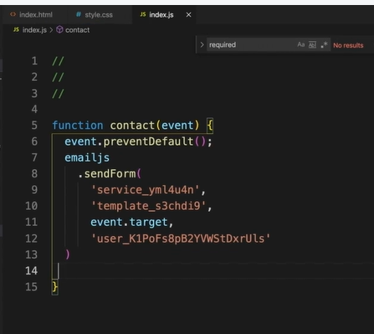

Following notes are on Module 4 section 3 for User-Posts-Starter

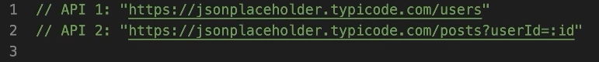

To view any of the above APIs do:

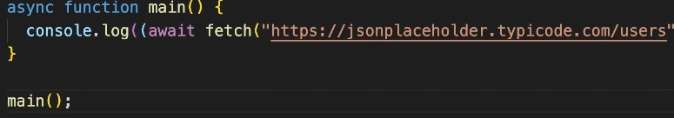

Await -> awaiting information from the BackEnd
Then we convert DATA into HTML
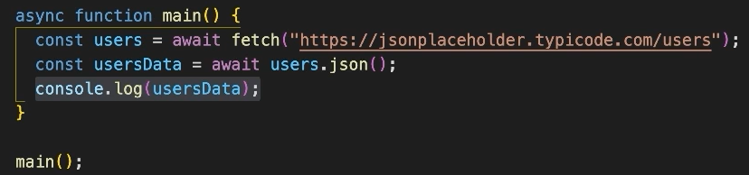

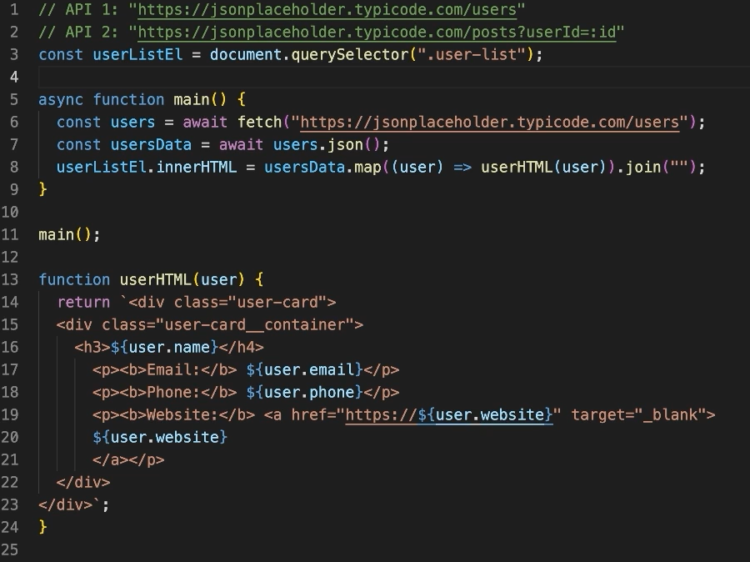
Everything in between the <div> is taken from HTML i.e. index.html

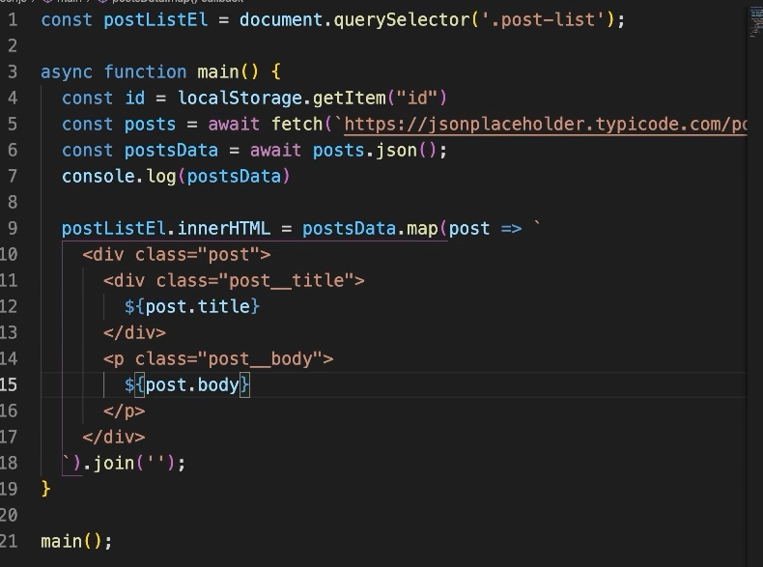

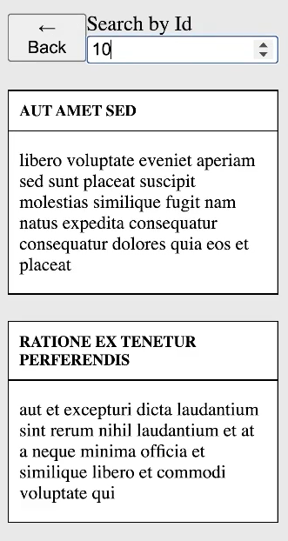

Simplified:
